EXPERIMENT DETAILS
Project Code | Folder Number | Experiment Number | Start Date & Time | Step Number
GA4136 | D01 | GA4136/D01/245 | 21/11/2024 07:43 am | 2

Experiment Precautions
null

Objective
A

Experiment Category
feasibility

Literature References
Aaa

Reaction Scheme
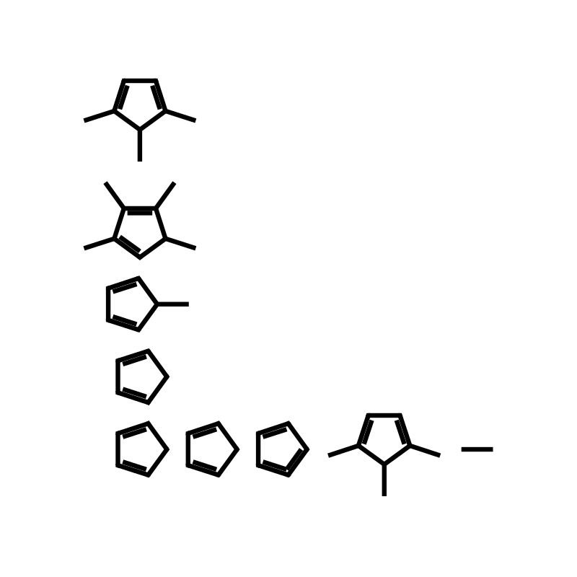

Raw Materials
S.No | Material Name | CAS Number | Molecular Formula | Mol. Wt | Quantity | UoM | Moles | Equivalents | Wt/Wt | Source
1 | A | NA | H | 1.54 | 2.44 | MT | 1.5894 | 1.57 | NA | NA

Solvents & Other Materials
S.No | Material Name | CAS Number | Molecular Formula | Mol. Wt | Quantity | UoM | Moles | Equivalents | Wt/Wt | Source

PROCEDURE

Reactions
S.No | Experiment | Observation

Work-up
S.No | Experiment | Observation

Isolations
S.No | Experiment | Observation

Analyses
S.No | Type of Test | Result

COMMENTS
S.No | Product Name | Product Formed | Quantity | UoM | Purity % | MW | Mol. Formula | Actual Yield % | Th. Yield%

Remarks

Experiment Closure
End Date & Time: 21/11/2024 07:46 am
Done by: Kishore

